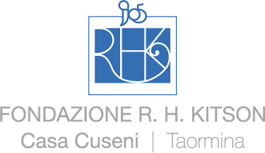

CASA CUSENI, MUSEO DELE BELLE ARTI E DEL GRAND TOUR DELLA CITTÀ DI TAORMINA

Thank you for having visited the Museum. We would like to take a few minutes of your time and ask you to fill out this simple questionnaire. Your answers will help us offer better services.

Is this your first visit to the Museum?

Yes |  | No

How did you learn about the Museum?

From a publication/guidebook (which one)____________________________________
From friends/relatives
Through the Internet
From a brochure/poster
From a magazine/newspaper article (which one)________________________________
From radio/TV
By chance, walking past the Museum
Other (please explain) ____________________________________________________

How did you visit the Museum?

With an |  | Alone |  | With your partner |  | With family |  | With relatives/friends
organized group |  |  |  |  |  | (children)

Why did you visit the Museum?

Specific interest in the collection
As part of a city/area tour
For professional/study purposes
To accompany friends/relatives
To see an exhibition or participate in one of the programs
To pass leisure time
Other (please explain)__________________________________

How long was your visit?

Less than 30 minutes |  | From 30 minutes to 1 hour |  | From 1 to 2 hours |  | More than 2 hours

In general, how do you rate today’s visit?

Unsatisfactory |  | Fair |  | Good |  | Very satisfactory

Next page >>>>>
How do you rate the following services?
 | Unsatisfactory |  |  | Fair |  |  | Good |  |  | Very satisfactory
Information
(panels, captions, leaflets)

Settings
(lighting, arrangement of the works of art)
Staff courtesy and professionalism

Street signs and directions to the Museum

Where do you live?

In this province
Elsewhere in Italy (please specify province)____________________________________________
Other country (please specify)______________________________________________________

Sex
Male |  | Female

Age

Less than 18 |  | Between 18 and 30 |  | Between 31 and 45 |  | Between 46 and 65 |  | over 65

Education

Elementary |  | Middle high school
High school |  | University or post graduate degree

What did you enjoy most in the Museum?

___________________________________________________________________________________

What do you think could be improved in the Museum?

___________________________________________________________________________________

Other comments and suggestions:

___________________________________________________________________________________

Date and time of your visit _______________________ Thank you for your cooperation!

